Data Analytics Assignment
Text Analysis
Name: Ankit Dimri
Roll No: 17BCS004

data: From Kaggle
about: 1490 tweets by people on Demonitaztion

source code:

library (stringr)
library (BSDA)

# Import dataset
df = read.csv ("demonetization-tweets.csv")

# Display Dataset
head (df)
> head (df)
text favorited favoriteCount
1 rt rssurjewala critical question was paytm informed about demonetization edict by pm it s clearly fishy and requires full disclosure amp FALSE 0
2 rt hemant 80 did you vote on demonetization on modi survey app FALSE 0
3 rt roshankar former finsec rbi dy governor cbdt chair harvard professor lambaste demonetization if not for aam aadmi listen to th FALSE 0
4 rt ani news gurugram haryana post office employees provide cash exchange to patients in hospitals demonetization t co ugmxup9 FALSE 0
5 rt satishacharya reddy wedding mail today cartoon demonetization reddywedding t co u7glnrq31f FALSE 0
6 derekscissors1 india s demonetization blackmoney a symptom not the disease t co hsl6ihj0qe via ambazaarmag FALSE 0
replyToSN created truncated replyToSID id replyToUID statusSource
1 <NA> 2016-11-23 18:40:30 FALSE NA 8.014957e+17 NA <a href="http://twitter.com/download/android" rel="nofollow">Twitter for Android</a>
2 <NA> 2016-11-23 18:40:29 FALSE NA 8.014957e+17 NA <a href="http://twitter.com/download/android" rel="nofollow">Twitter for Android</a>
3 <NA> 2016-11-23 18:40:03 FALSE NA 8.014955e+17 NA <a href="http://twitter.com/download/android" rel="nofollow">Twitter for Android</a>
4 <NA> 2016-11-23 18:39:59 FALSE NA 8.014955e+17 NA <a href="http://twitter.com/download/android" rel="nofollow">Twitter for Android</a>
5 <NA> 2016-11-23 18:39:39 FALSE NA 8.014954e+17 NA <a href="http://cpimharyana.com" rel="nofollow">CPIMBadli</a>
6 DerekScissors1 2016-11-23 18:39:11 FALSE NA 8.014953e+17 2586266100 <a href="http://twitter.com" rel="nofollow">Twitter Web Client</a>
screenName retweetCount isRetweet retweeted created_date hour isRetweetNum retweetedNum tweet
1 HASHTAGFARZIWAL 331 TRUE FALSE 2016-11-23 18 1 0 1
2 PRAMODKAUSHIK9 66 TRUE FALSE 2016-11-23 18 1 0 1
3 rahulja13034944 12 TRUE FALSE 2016-11-23 18 1 0 1
4 deeptiyvd 338 TRUE FALSE 2016-11-23 18 1 0 1
5 CPIMBadli 120 TRUE FALSE 2016-11-23 18 1 0 1
6 ambazaarmag 0 FALSE FALSE 2016-11-23 18 0 0 1

# Size of the dataframe
summary (df)
> summary (df)
text favorited favoriteCount replyToSN created truncated replyToSID id
Length:14940 Mode :logical Min. : 0.000 narendramodi : 77 2017-04-18 15:51:06: 45 Mode :logical Min. :2.210e+10 Min. :8.010e+17
Class :character FALSE:14940 1st Qu.: 0.000 PMOIndia : 21 2017-04-12 16:15:46: 32 FALSE:14243 1st Qu.:8.015e+17 1st Qu.:8.013e+17
Mode :character Median : 0.000 sardesairajdeep: 17 2017-04-19 11:36:07: 22 TRUE :697 Median :8.529e+17 Median :8.015e+17
Mean : 1.071 ArvindKejriwal : 16 2017-04-19 15:08:24: 22 Mean :8.384e+17 Mean :8.256e+17
3rd Qu.: 0.000 centerofright : 13 2016-11-23 06:03:53: 20 3rd Qu.:8.540e+17 3rd Qu.:8.535e+17
Max. :3166.000 (Other) : 958 2016-11-23 09:57:50: 14 Max. :8.555e+17 Max. :8.555e+17
NA's :13838 (Other) :14785 NA's :14054
replyToUID statusSource screenName retweetCount isRetweet
Min. :1.918e+06 <a href="http://twitter.com/download/android" rel="nofollow">Twitter for Android</a>:7642 Stupidosaur : 47 Min. : 0.0 Mode :logical
1st Qu.:3.915e+07 <a href="http://twitter.com" rel="nofollow">Twitter Web Client</a> :2548 dhruvbhim : 20 1st Qu.: 1.0 FALSE:3948
Median :1.458e+08 <a href="http://twitter.com/download/iphone" rel="nofollow">Twitter for iPhone</a> :2093 mituamin : 20 Median : 40.0 TRUE :10992
Mean :4.303e+16 <a href="https://about.twitter.com/products/tweetdeck" rel="nofollow">TweetDeck</a> : 492 DipendraDipzo: 19 Mean : 223.8
3rd Qu.:1.480e+09 <a href="https://mobile.twitter.com" rel="nofollow">Twitter Lite</a> : 263 gauravcam : 19 3rd Qu.: 197.0
Max. :8.543e+17 <a href="https://mobile.twitter.com" rel="nofollow">Mobile Web (M5)</a> : 178 AmiKanu : 18 Max. :5170.0
NA's :13838 (Other) :1724 (Other) :14797
retweeted created_date hour isRetweetNum retweetedNum tweet
Mode :logical Min. :2016-11-22 Length:14940 Min. :0.0000 Min. :0 Min. :1
FALSE:14940 1st Qu.:2016-11-23 Class :character 1st Qu.:0.0000 1st Qu.:0 1st Qu.:1
Median :2016-11-23 Mode :character Median :1.0000 Median :0 Median :1
Mean :2017-01-28 Mean :0.7357 Mean :0 Mean :1
3rd Qu.:2017-04-16 3rd Qu.:1.0000 3rd Qu.:0 3rd Qu.:1
Max. :2017-04-21 Max. :1.0000 Max. :0 Max. :1

nrow (df)
> nrow (df)
[1] 14940
ncol (df)
> ncol (df)
[1] 19

# Displaying some of the tweets
head (df [,1])
> head (df [,1])
[1] "rt rssurjewala critical question was paytm informed about demonetization edict by pm it s clearly fishy and requires full disclosure amp "
[2] "rt hemant 80 did you vote on demonetization on modi survey app "
[3] "rt roshankar former finsec rbi dy governor cbdt chair harvard professor lambaste demonetization if not for aam aadmi listen to th "
[4] "rt ani news gurugram haryana post office employees provide cash exchange to patients in hospitals demonetization t co ugmxup9 "
[5] "rt satishacharya reddy wedding mail today cartoon demonetization reddywedding t co u7glnrq31f"
[6] " derekscissors1 india s demonetization blackmoney a symptom not the disease t co hsl6ihj0qe via ambazaarmag"

# Clean the dataset
tweets = df [,1]
tweets = str_replace_all (tweets, "[^[:alnum:]]", " ")
tweets
> head (tweets)
[1] "RT rssurjewala Critical question Was PayTM informed about Demonetization edict by PM It s clearly fishy and requires full disclosure amp "
[2] "RT Hemant 80 Did you vote on Demonetization on Modi survey app "
[3] "RT roshankar Former FinSec RBI Dy Governor CBDT Chair Harvard Professor lambaste Demonetization If not for Aam Aadmi listen to th "
[4] "RT ANI news Gurugram Haryana Post office employees provide cash exchange to patients in hospitals demonetization https t co uGMxUP9 "
[5] "RT satishacharya Reddy Wedding mail today cartoon demonetization ReddyWedding https t co u7gLNrq31F"
[6] " DerekScissors1 India s demonetization Blackmoney a symptom not the disease https t co HSl6Ihj0Qe via ambazaarmag"

df [,1] = tolower (tweets)
head (df)
df$created_date=as.Date (df$created, format = '%Y-%m-%d %H:%M:%S')
df$hour = format (as.POSIXct (df$created, format = "%Y-%m-%d %H:%M:%S"), "%H")
df$isRetweetNum = ifelse (df$isRetweet == FALSE, 0, 1)
df$retweetedNum = ifelse (df$retweeted == FALSE, 0, 1)
df$tweet = c (1)

# Plotting the trends
options (repr.plot.width=6, repr.plot.height=4)
HourFrame = as.data.frame (table (df$hour))
colnames (HourFrame) = c ("Hour","TweetCount")
HourFrame$Hour = as.numeric (HourFrame$Hour)
y=ddply (df, .(df$hour), numcolwise(sum))
HourFrame$retweetedNum=y$isRetweetNum
ggplot (HourFrame, aes (x = Hour)) + geom_line (aes (y = TweetCount, colour = "TotalTweets")) + geom_line (aes (y = retweetedNum))

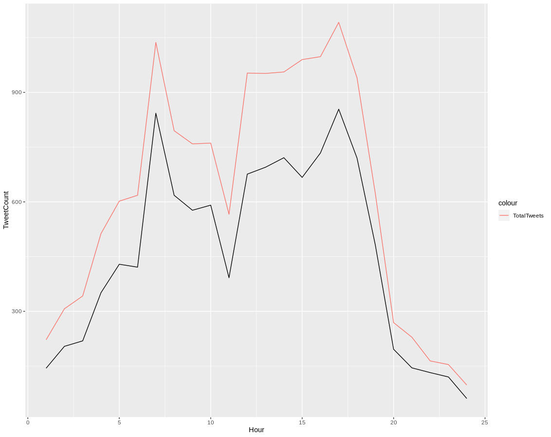
y = ddply (df, .(screenName), numcolwise (sum))
popularUsers = y [, c ("screenName", "retweetCount", "tweet")]
popularUsers = popularUsers [ order ( -popularUsers$retweetCount),]
popularUsers = head (popularUsers, n = 10)
> popularUsers
screenName retweetCount tweet
1141 apoliceshanigm2 7677 2
5166 Krishna20977027 7677 2
7012 ParthPa07241800 5916 13
134 1SunnyElias 5170 1
8020 rayyat9tfoi 5170 1
9692 subhashjsr 5170 1
9942 sxP6DbxfufguCc0 5170 1
8509 sainath_kits 4280 11
8487 SahilBalu456 3772 2
9850 SurenderBalu1 3772 2

#Most Replies
Replies = df [is.na (df$replyToSN) == FALSE,]
y = ddply (Replies, .(replyToSN), numcolwise(sum))
Replies = y [, c ("replyToSN", "tweet")]
Replies = Replies [order (-Replies$tweet),]
Replies = head (Replies, n = 20)
colnames (Replies) = c ("User", "RepliesReceived")
> Replies
User RepliesReceived
369 narendramodi 77
421 PMOIndia 21
518 sardesairajdeep 17
66 ArvindKejriwal 16
114 centerofright 13
377 ndtv 12
49 ANI_news 10
608 timesofindia 10
125 CNNnews18 9
180 evanspiegel 9
558 Stupidosaur 9
264 jamewils 7
41 AmmU_MaanU 6
99 BJP4India 6
276 John_Miller_GLR 6
313 madmanweb 6
370 NarendraModi98 6
63 arunjaitley 5
153 digvijaya_28 5
161 dna 5

some_txt <- gsub ("(RT|via)((?:\\b\\w*@\\w+)+)", "", df$text)
some_txt <- gsub ("http[^[:blank:]]+", "", some_txt)
df [,1] = some_txt

mysentiment <- get_nrc_sentiment ((some_txt))
Sentimentscores <- data.frame (colSums (mysentiment [,]))
names (Sentimentscores) <- "Score"
SentimentScores <- cbind ("sentiment" = rownames (Sentimentscores), Sentimentscores)
rownames (SentimentScores) <- NULL
ggplot (data = SentimentScores, aes (x = sentiment, y = Score)) + geom_bar (aes (fill = sentiment), stat = "identity") + theme (legend.position = "none") + xlab("Sentiments") + ylab ("scores") + ggtitle ("Total sentiment based on scores")

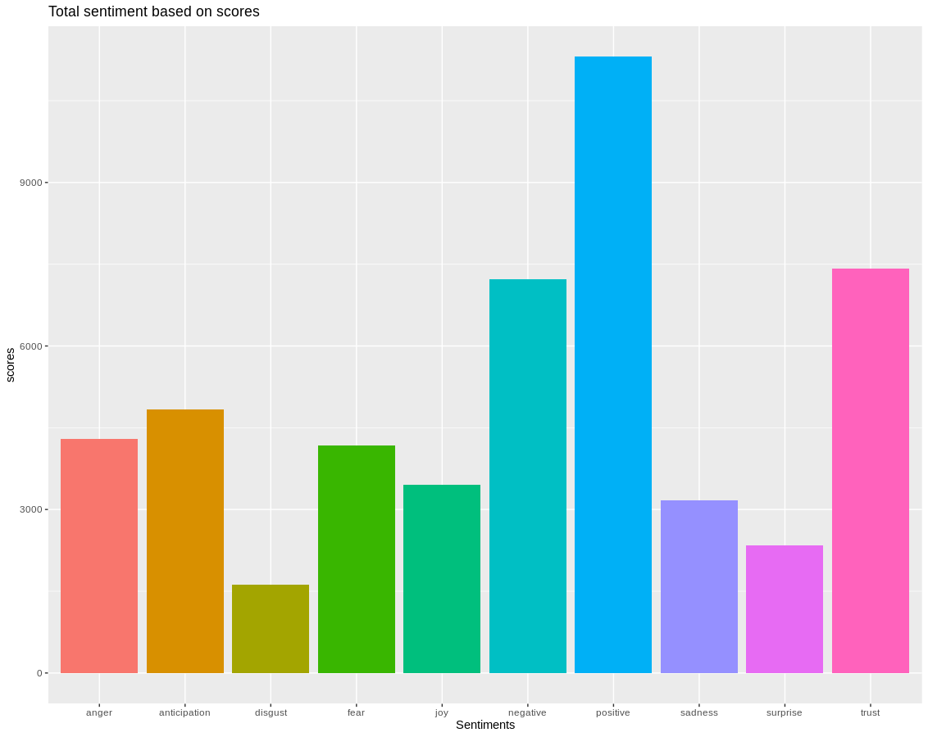
t.test(mysentiment['positive'], mu = 0, alternative = "two.sided")
> mysentiment
anger anticipation disgust fear joy sadness surprise trust negative positive
1 0 0 0 1 0 0 0 0 1 2
2 1 1 0 0 1 1 1 1 1 1
3 0 0 0 0 0 0 0 2 0 1
4 1 1 0 1 1 0 0 3 0 3
5 0 1 0 0 0 0 0 0 0 0
6 1 0 1 1 0 1 0 0 2 0
7 0 0 0 0 0 0 1 1 0 0
8 0 0 0 0 0 0 0 0 0 1
9 1 1 0 0 1 0 0 1 1 1
10 1 0 0 1 0 1 0 0 1 2
11 1 1 0 0 1 0 0 1 1 1
12 0 0 0 0 0 0 0 0 0 1
13 0 0 0 0 0 0 0 0 0 0
14 0 0 0 0 0 0 0 0 0 0
15 1 0 0 0 0 0 0 0 1 0
16 1 0 1 1 0 1 0 0 1 0
17 0 0 0 0 0 0 0 2 0 1
18 0 0 0 0 0 0 0 0 0 1
19 1 2 0 0 2 2 2 3 2 3
20 0 0 0 0 0 0 0 2 0 1
21 1 1 0 0 1 1 1 1 1 1
22 0 0 0 0 0 0 0 2 0 1
23 0 0 0 0 0 0 0 0 0 1
24 0 2 0 1 1 0 0 1 1 2
25 1 1 0 0 1 1 1 1 1 1
26 0 0 0 0 0 0 0 2 0 1
27 1 0 0 1 0 1 0 0 2 0
28 0 0 0 0 0 0 0 2 0 1
29 1 0 0 1 0 1 0 0 2 0
30 1 0 1 1 0 1 1 0 1 0
31 1 1 0 0 1 1 1 1 1 1
32 0 0 0 0 0 0 0 0 0 0
33 0 1 0 0 0 1 0 1 1 1
34 0 0 0 0 0 0 0 0 0 0
35 1 2 0 0 1 1 1 1 1 1
36 0 0 0 0 0 0 0 0 0 0
37 1 0 0 1 0 1 0 0 2 0
38 0 1 0 0 0 1 0 2 2 0
39 0 0 0 0 0 0 0 0 0 1
40 0 0 0 0 0 0 0 0 0 0
41 1 0 0 0 0 0 0 0 1 0
42 0 1 0 0 0 1 0 3 2 0
43 0 0 0 0 0 0 0 0 0 0

positive_mean = mean(mysentiment$positive)
sigmap = sd(mysentiment$positive)
negative_mean = mean(mysentiment$negative)
sigman = sd(mysentiment$negative)
countp = length(mysentiment$positive)
countn = length(mysentiment$negative)

z_calcs1 = zsum.test(mean.x = positive_mean,sigma.x = sigmap,n.x = countp,mean.y = negative_mean,sigma.y =sigman,n.y = countn )
print(z_calcs1)
> print(z_calcs1)

Two-sample z-Test

data: Summarized x and y
z = 29.588, p-value < 2.2e-16
alternative hypothesis: true difference in means is not equal to 0
95 percent confidence interval:
0.2553148 0.2915393
sample estimates:
mean of x mean of y
0.7568942 0.4834672

